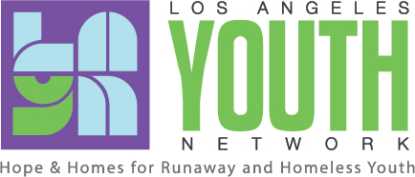
News Release

FOR IMMEDIATE RELEASE
Media Contact:
Raynetta Smith
Develop & Communications Manager
(323) 467-8466
rsmith@layn.org

Los Angeles Youth Network Awarded International Accreditation

Los Angeles – December 19, 2016 – Los Angeles Youth Network (LAYN), a local nonprofit serving runaway, homeless and foster youth is pleased to announce it has been awarded a three-year accreditation from the Commission on Accreditation of Rehabilitation Facilities (CARF), valid through 2019.
Three years is the maximum length of accreditation possible from CARF, an organization whose primary responsibility is to ensure that nonprofit agencies serving individuals living with disadvantaging conditions are meeting nationally-recognized program standards.
“CARF accreditation reflects that the practices of LAYN are based on high-quality standards and ensure that premium level services are provided to the youth we serve,” said Mark Supper, President & CEO of LAYN. “This achievement recognizes our continued excellence as an industry leader and the dedication of our staff to help improve the quality of life for our youth.”
LAYN’s staff, programs, facilities, business and ethical practices underwent a rigorous three-day review process, which evaluated 20 areas of exceptional performance. A CARF team of industry peers conducted the on-site survey to observe organizational practices, review documentation, and suggest ways to improve operations and service delivery.

Because CARF accreditation is designed to demonstrate a provider's conformance to nationally and internationally accepted standards, accreditation can significantly reduce governmental monitoring, help to streamline regulation processes, and assist in identifying additional funding for an organization who meets the standards. A process that may take up to 14 months --- LAYN was able to obtain accreditation in less than one year.

For more information on CARF, visit www.carf.org.

About Los Angeles Youth Network
Since 1985, Los Angeles Youth Network (LAYN) has served runaway, foster and other youth experiencing homelessness ages 12-21 that includes emergency, group and long-term housing. LAYN provides comprehensive programs and services teaching independent living skills and resources necessary for youth to lead productive lives, while offering a wide array of educational and enrichment programs. In addition, LAYN operates a high school in partnership with the Los Angeles Unified School District. For more information, visit www.layn.org.

About CARF
The mission of CARF is to promote the quality, value, and optimal outcomes of services through a consultative accreditation process and continuous improvement services that center on enhancing the lives of persons served
# # #

